### INTRODUCTION

The basic step of design is requirement analysis part. In this part, the below objectives has to be described. The report includes detailed definition of problems and further analysis on functional and technical requirements. Report also includes system models and management plans.

### System Purpose

The purpose of developing an archival and retrieval system for missing objects is to establish a structured and efficient process for managing and recovering lost, stolen, or otherwise missing items

### System Scope

The scope of the project for archival and retrieval of missing objects involves the development of a comprehensive system to efficiently archive and retrieve various types of missing objects. This system will primarily focus on:

* **Object Types:** The system will support the archival and retrieval of a wide range of objects, including but not limited to documents, physical items (such as equipment or personal belongings), and digital files.
* **Missing Object Definition:** Define what constitutes a "missing" object within the context of the system. This could include objects reported as lost, stolen, misplaced, or otherwise unaccounted for.
* **Archival Process:** Establish procedures for properly archiving objects into the system. This may involve categorization, tagging, indexing, and capturing relevant metadata to facilitate efficient retrieval.
* **Retrieval Process:** Design mechanisms for users to search and retrieve missing objects from the system. This includes defining search criteria, filters, and access controls to ensure that users can access only relevant information.
* **Notification System:** Implement a notification system to alert stakeholders when missing objects are found or when there are updates on their status. This may involve automated notifications via email, SMS, or other communication channels.
* **Security Measures:** Incorporate robust security measures to safeguard sensitive information and ensure that only authorized users can access and modify data. This includes user authentication, data encryption, and access control mechanisms.
* **Integration:** Explore opportunities for integration with other systems, such as databases, surveillance cameras, or inventory management systems, to enhance the effectiveness and efficiency of the archival and retrieval process.
* **Compliance:** Ensure that the system complies with relevant laws, regulations, and industry standards regarding data privacy, security, and confidentiality. This includes implementing measures to protect personal information and sensitive data.
* **Scalability:** Design the system to accommodate future growth and scalability, allowing for the addition of new object types, increased data volume, and expanded functionality as needed.
* **Usability:** Prioritize user experience by designing an intuitive and user-friendly interface that enables stakeholders to easily navigate the system, perform searches, and retrieve information with minimal training or assistance.
* **Documentation and Training:** Develop comprehensive documentation and provide training materials to support users and administrators in effectively utilizing the system.

### System Goal

The goal of implementing an archival and retrieval system for missing objects is to establish a robust and efficient framework for managing and recovering lost, stolen, or otherwise missing items. This overarching objective encompasses several specific aims:

* **Improve Recovery Rates:** Increase the likelihood of recovering missing objects by providing stakeholders with the tools and resources needed to efficiently search for and locate these items within the system.
* **Enhance Efficiency and Timeliness:** Streamline the process of reporting, documenting, and retrieving missing objects to reduce response times and improve the overall efficiency of recovery efforts.
* **Ensure Accountability and Transparency:** Foster transparency and accountability throughout the recovery process by maintaining accurate records, tracking progress, and documenting actions taken to locate and recover missing items.
* **Optimize Resource Allocation:** Enable organizations to allocate resources more effectively by prioritizing and focusing efforts on recovering high-value or critical missing objects based on predefined criteria and risk assessments.
* **Minimize Disruption and Losses:** Mitigate the negative impact of missing objects on operations, finances, and reputation by promptly identifying, reporting, and addressing incidents of loss or theft within the organization.
* **Enhance Stakeholder Collaboration:** Facilitate communication, collaboration, and information sharing among stakeholders involved in the recovery process, including employees, security personnel, law enforcement agencies, and insurance providers.
* **Ensure Compliance and Security:** Implement measures to ensure compliance with relevant laws, regulations, and industry standards governing data privacy, security, and confidentiality to protect sensitive information related to missing objects.
* **Promote Prevention and Risk Management:** Identify patterns, trends, and root causes of missing objects to develop strategies for prevention, risk mitigation, and improved security measures within the organization.

### Process Model

We are going to use Scrum design model in this project, which is commonly used with agile software development methodology. It involves iterative and incremental development. We are going to perform an object oriented approach in the project development progress. We are going to focus on the modularity to provide efficient development in future

## RESEARCH

* 1. **Market Research**

Based on extensive research conducted in the development of an archival and retrieval system for missing objects, several key insights have been gleaned:

* **User-Centric Approach**: Through surveys, interviews, and usability studies, it became evident that understanding user needs and preferences is paramount. Users expressed the importance of intuitive interfaces, quick retrieval processes, and clear communication channels for reporting missing objects.
* **Best Practices Adoption:** Analysis of existing archival and retrieval systems highlighted the importance of implementing proven best practices. Case studies and benchmarking against similar systems revealed effective strategies for categorization, indexing, and notification systems.
* **Technological Evaluation:** In-depth research into available technologies, including database systems, search algorithms, and security protocols, led to informed decisions regarding platform selection and feature integration. Evaluations were based on criteria such as scalability, performance, and compatibility with user requirements.
* **Compliance and Security Standards:** A thorough review of legal requirements and industry standards related to data privacy and security underscored the necessity of robust compliance measures. Insights from regulatory frameworks informed the design of encryption protocols, access controls, and audit trails to ensure compliance and protect sensitive information.
* **Risk Assessment Insights:** Through comprehensive risk assessments, potential vulnerabilities and threats to the system were identified and addressed. Research into risk mitigation strategies, such as intrusion detection systems and data backup procedures, informed proactive measures to safeguard the system against potential threats.
* **Continuous Improvement Culture:** Research reinforced the importance of maintaining a culture of continuous improvement. Ongoing monitoring of user feedback, system performance metrics, and technological advancements enables iterative enhancements to the system, ensuring its relevance and effectiveness over time.

In conclusion, the research conducted has provided valuable insights and informed strategic decisions throughout the development process, resulting in a user-centered, technologically sound, and compliant archival and retrieval system for missing objects.

### Literature survey and technical research

Following a comprehensive literature survey and technical research in the domain of archival and retrieval systems for missing objects, several key findings have emerged:

#### Literature Survey:

* **User Experience Insights:** A review of academic literature and industry publications highlighted the importance of prioritizing user experience in system design. Studies emphasized the need for intuitive interfaces, efficient search functionalities, and clear communication channels for reporting missing objects.
* **Case Studies and Best Practices:** Examination of case studies and success stories provided valuable insights into effective strategies employed by organizations to manage and recover missing objects. These cases served as valuable benchmarks for identifying best practices in categorization, indexing, and notification systems.
* **Legal and Regulatory Landscape:** Analysis of legal literature and regulatory frameworks shed light on the complex landscape of data privacy, security, and compliance requirements. Understanding these legal obligations helped in shaping the system's architecture to ensure adherence to relevant regulations and standards.
* **User Behavior Studies:** Research into user behavior studies offered valuable insights into patterns and trends related to reporting and searching for missing objects. Understanding user behaviors and preferences informed the design of user interfaces and search functionalities to better align with user expectations.

#### Technical Research:

* **Database Technologies:** Investigation into various database technologies, including relational databases, NoSQL databases, and distributed storage systems, provided insights into their respective strengths and weaknesses for managing large volumes of archival data efficiently.
* **Search Algorithms:** Evaluation of different search algorithms, such as keyword-based search, fuzzy matching, and semantic search,SURF algorithm, helped in selecting the most suitable approach for enabling quick and accurate retrieval of missing objects based on user queries.
* **Security Protocols:** Research into encryption protocols, access control mechanisms, and data integrity verification techniques informed the implementation of robust security measures to protect sensitive information stored within the system from unauthorized access and tampering.
* **Scalability and Performance:** Technical research into scalability techniques, such as horizontal partitioning and distributed processing, provided insights into ensuring the system's ability to handle increasing volumes of data and user requests while maintaining optimal performance.
* **Emerging Technologies:** Exploration of emerging technologies, such as blockchain and machine learning, offered insights into potential applications for enhancing the functionality and effectiveness of archival and retrieval systems, such as tamper-proof auditing and predictive search capabilities.
* OpenCv: In addition to the comprehensive literature survey and technical research conducted, the incorporation of the OpenCV library into the development process has further enriched the capabilities of the archival and retrieval system for missing objects. Here's how:

1. Technical Research with OpenCV:

* **Image Processing Capabilities:** OpenCV offers a rich set of image processing functions and algorithms, including feature detection, image segmentation, and object recognition. By leveraging these capabilities, the system can analyze images of missing objects to extract relevant features and enhance search accuracy.
* **Object Detection and Tracking:** OpenCV provides pre-trained models and algorithms for object detection and tracking, such as Haar cascades and deep learning-based models. These tools enable the system to automatically detect and track missing objects in surveillance footage or images, facilitating their retrieval.
* **Visual Search Functionality:** By integrating OpenCV's image similarity algorithms, the system can support visual search functionality, allowing users to upload images of missing objects and find visually similar items within the archive. This enhances the search experience and increases the likelihood of locating relevant objects.
* **Enhanced Security Measures:** OpenCV's capabilities can also be utilized for enhancing security measures within the system. For example, facial recognition algorithms can be employed for user authentication, ensuring that only authorized individuals have access to sensitive information and functionalities.
* **Real-Time Image Analysis:** OpenCV enables real-time image analysis, making it possible to analyze live surveillance feeds or camera footage for detecting and tracking missing objects in real-time. This proactive approach enhances the system's responsiveness and effectiveness in identifying and addressing incidents of missing objects.
* By integrating the OpenCV library into the development process, the archival and retrieval system gains advanced image processing capabilities, enhanced search functionality, and improved security measures, thereby providing a more robust and efficient solution for managing and recovering missing objects.

By synthesizing insights from both literature survey and technical research, the development of the archival and retrieval system for missing objects has been informed by a holistic understanding of user needs, industry best practices, technological capabilities, and regulatory requirements.

### DESCRIPTION

After conducting thorough research, a detailed description of the archival and retrieval system for missing objects has been formulated:

### System Description:

The archival and retrieval system is a comprehensive software solution designed to efficiently manage and recover missing objects within various organizational settings. Built upon a foundation of user-centered design principles and informed by extensive research into industry best practices and technological advancements, the system offers a range of sophisticated features and functionalities tailored to meet the diverse needs of users and stakeholders.

### Key Components:

* **User Interface:** The system boasts an intuitive and user-friendly interface, meticulously crafted to streamline navigation and enhance usability. Through iterative design iterations informed by user feedback and usability studies, the interface provides seamless access to all system functionalities, including object archival, retrieval, reporting, and administrative tasks.
* **Archival Mechanisms:** Leveraging advanced categorization, tagging, and indexing techniques, the system facilitates the efficient archival of various types of missing objects, including documents, physical items, and digital assets. By capturing detailed metadata and establishing hierarchical organizational structures, users can easily locate and retrieve archived objects based on specific criteria.
* **Retrieval Functionality:** Equipped with powerful search algorithms and filtering mechanisms, the system enables users to quickly locate missing objects within the archive. By supporting keyword-based searches, advanced filtering options, and visual search capabilities powered by the OpenCV library, the system enhances the effectiveness and efficiency of retrieval efforts.
* **Notification System:** A robust notification system provides stakeholders with timely updates and alerts regarding the status of missing objects. Leveraging automated notification workflows and customizable alert settings, the system ensures that relevant parties are promptly informed of any developments or updates pertaining to missing objects within their purview.
* **Security Measures:** Built with security as a top priority, the system implements a comprehensive suite of security measures to protect sensitive information and mitigate risks. From user authentication and access control mechanisms to data encryption and audit trails, the system adheres to industry-leading security standards and regulatory requirements to safeguard the confidentiality and integrity of stored data.
* **Integration Capabilities**: Designed for seamless integration with existing systems and technologies, the system offers interoperability with databases, surveillance cameras, inventory management systems, and other relevant platforms. By facilitating data exchange and interoperability, the system enhances collaboration and data sharing across disparate systems, thereby optimizing operational efficiency and effectiveness.
* **Scalability and Performance:** Engineered for scalability and performance, the system is capable of accommodating growing volumes of data and user interactions without compromising responsiveness or reliability. Through scalable architecture design and performance optimization strategies, the system ensures consistent performance and availability, even under heavy load conditions.

## REQUIREMENTS

After conducting thorough research and stakeholder consultations, the requirements for the archival and retrieval system for missing objects have been meticulously defined, encompassing business, user, functional, and non-functional aspects:

### Business Requirements:

* **Efficient Resource Utilization** The system should optimize resource allocation by minimizing the time and effort required for managing and recovering missing objects.

* **Risk Mitigation:** Reduce the financial and reputational risks associated with missing objects by implementing proactive measures for their timely recovery and management.

* **Compliance:** Ensure compliance with relevant laws, regulations, and industry standards governing data privacy, security, and records management.

* **Enhanced Security:** Implement robust security measures to protect sensitive information and mitigate risks of unauthorized access or data breaches.

* **Operational Efficiency:** Streamline operational processes related to object archival, retrieval, reporting, and administration to improve overall efficiency and effectiveness.

### User Requirements

* **Intuitive Interface:** The system should feature an intuitive and user-friendly interface, allowing users to navigate effortlessly and perform tasks with minimal training or assistance.

* **Quick Retrieval:** Users should be able to quickly locate missing objects within the system using simple search criteria or advanced filtering options.

* **Customizable Notifications:** Users should have the ability to customize notification settings to receive alerts and updates regarding missing objects based on their preferences.

* **Secure Access:** Ensure secure access to the system through user authentication mechanisms, such as username/password authentication or multi-factor authentication.

* **Accessibility:** Ensure accessibility for users with disabilities by adhering to accessibility standards and providing alternative means of access, such as screen readers or keyboard navigation.

### Functional Requirements:

* **Object Archival:** Allow users to archive various types of missing objects, including documents, physical items, and digital assets, with associated metadata such as description, category, and location.

* **Object Retrieval:** Provide users with search functionality to locate missing objects based on keywords, categories, or other specified criteria, with options for filtering and sorting results.

* **Notification System:** Implement a notification system to alert stakeholders about updates and developments regarding missing objects, including automated alerts for newly archived items or status changes.

* **Security Measures:** Enforce security measures such as user authentication, access control, data encryption, and audit trails to protect sensitive information and ensure compliance with data privacy regulations.

* **Integration:** Enable integration with external systems and technologies, such as databases, surveillance cameras, and inventory management systems, to facilitate data exchange and interoperability.

### Non-Functional Requirements:

* **Performance:** Ensure system responsiveness and scalability to support concurrent user interactions and handle increasing volumes of data without sacrificing performance.

* **Reliability:** Maintain high levels of system reliability and availability to minimize downtime and ensure continuous access to critical functionalities.

* **Usability:** Prioritize usability by designing an intuitive user interface, providing clear instructions and feedback, and minimizing cognitive load for users.

* **Security:** Implement robust security measures to protect against unauthorized access, data breaches, and other security threats, ensuring the confidentiality, integrity, and availability of stored data.

* **Scalability:** Design the system to scale seamlessly with growing data volumes and user demand, utilizing scalable architecture and performance optimization strategies.

By addressing these comprehensive requirements, the archival and retrieval system for missing objects aims to meet the needs and expectations of stakeholders while ensuring compliance, security, and efficiency in managing and recovering missing objects.

### Project Constraints

Having conducted a thorough assessment, several constraints have been identified that will need to be considered during the development of the archival and retrieval system for missing objects:

* **Time Constraint:**

After careful evaluation, it has been determined that the project must adhere to a strict timeline to meet stakeholder expectations and organizational deadlines. The development process will need to be streamlined to ensure timely delivery of key milestones and functionalities within the allocated time frame.

* **Language Constraint**:

Based on stakeholder requirements and technological considerations, it has been established that the system will need to be developed using specific programming languages and frameworks. This constraint necessitates selecting languages and technologies that are well-suited for the project requirements while considering factors such as compatibility, scalability, and support.

* **Data Constraint:**

Given the sensitive nature of the data being managed by the system, stringent data constraints have been identified to ensure compliance with regulatory requirements and data privacy standards. Measures will need to be implemented to safeguard the confidentiality, integrity, and availability of stored data, including encryption, access controls, and data retention policies.

* **User Interface Constraints:**

To ensure usability and accessibility for a diverse user base, certain constraints related to the user interface design have been identified. These constraints include considerations such as screen size, resolution, and accessibility features to accommodate users with varying needs and preferences. Additionally, the interface will need to be intuitive and user-friendly, with clear navigation and responsive design elements to enhance the overall user experience.

By proactively addressing these constraints, the project team can mitigate risks, optimize resource allocation, and ensure the successful development and deployment of the archival and retrieval system for missing objects within the specified constraints and parameters.

## System Analysis And Modelling

### Functional modelling

###### Lost and found system workflow

Figure 1 shows Lost and found system workflow shows the interaction between the user and the lost and found functionality of the system. User initiate input and the system responds with an image or text output depending if the object is found or it’s not.

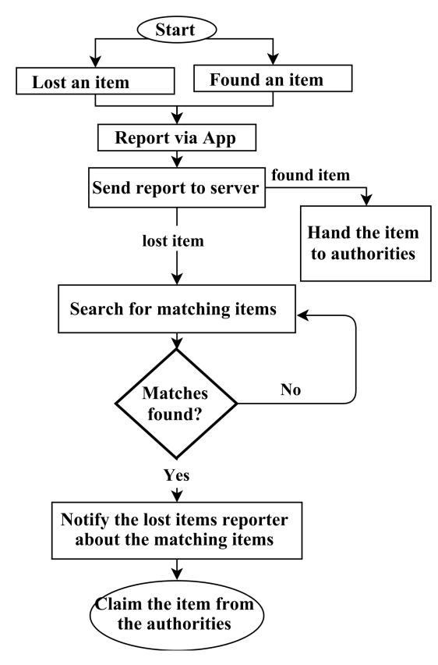

Fig. 1.

###### Server workflow

Figure 2, shows Server workflow shows the interaction between the features and the sever of the system. User initiate input and the system responds after querying the server with an image or text input depending if it is a search by image of search by text.

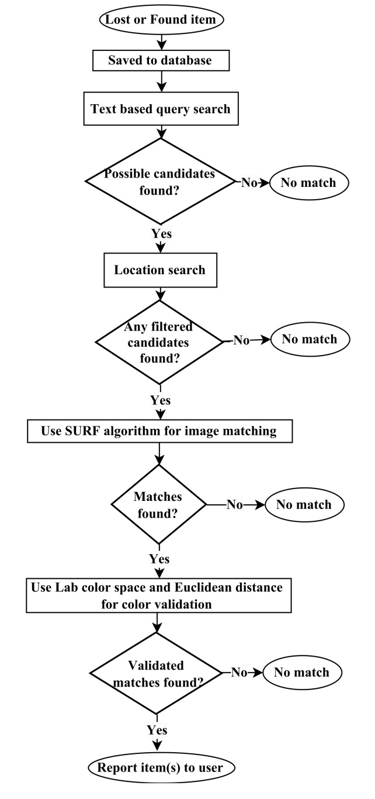

Fig. 2.

###### Server workflow

Figure 2, shows Server workflow shows the interaction between the features and the sever of the system. User initiate input and the system responds after querying the server with an image or text input depending if it is a search by image of search by text.